SUPPLEMENTARY FILE

Supplement Figure 1 Disposition of patients.
IVT-AFL, intravitreal aflibercept.
*307 patients were retrospectively enrolled and 286 patients were prospectively enrolled.
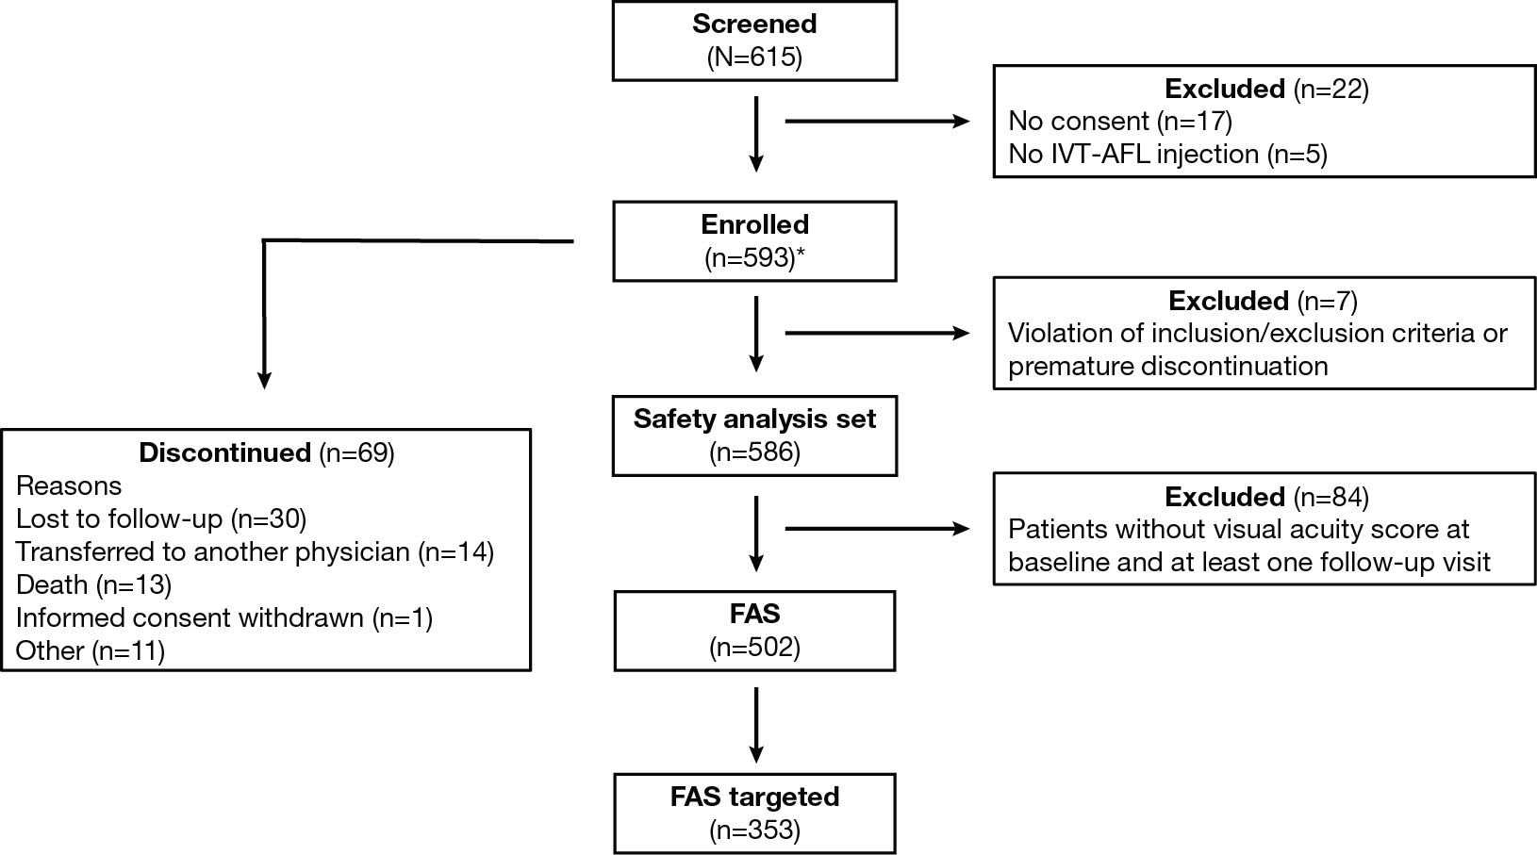

Supplement Figure 2 Patients (full analysis set [FAS] targeted) receiving intravitreal aflibercept and stratified by final visual acuity categories at month 12.
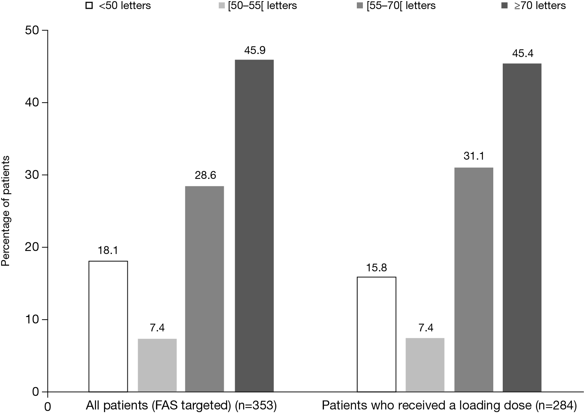
Supplement Table 1 Visual acuity conversion chart.
Equivalent notations |  | True SNELLEN fractions (numerator = test distance) |  |  |  |  |  | Magnification requirement |  | Visual acuity score
Decimal | US | 6.3 m | 6 m | 5 m | 4 m | 1 m | Monoyer | MAR(1/v) | LogMAR | Letter count
1.6 | 20/12.5 | 6.3/4 | 6/3.8 | 5/3.2 | 4/2.5 | 1/0.63 | 16/10 | 0.63 | -0.2 | 95
1.25 | 20/16 | 6.3/5 | 6/4.8 | 5/4 | 4/3 | 1/0.8 | 12.5/10 | 0.8 | -0.1 | 90
1.0 | 20/20 | 6.3/6.3 | 6/6 | 5/5 | 4/4 | 1/1 | 10/10(9/10) | 1.0 | 0 | 85
0.8 | 20/25 | 6.3/8 | 6/7.5 | 5/6.3 | 4/5 | 1/1.25 | 8/10(7/10) | 1.25 | 0.1 | 80
0.63 | 20/32 | 6.3/10 | 6/9.5 | 5/8 | 4/6.3 | 1/1.6 | 6.3/10 | 1.6 | 0.2 | 75
0.5 | 20/40 | 6.3/12.5 | 6/12 | 5/10 | 4/8 | 1/2 | 5/10 | 2.0 | 0.3 | 70
0.4 | 20/50 | 6.3/16 | 6/15 | 5/12.5 | 4/ 10 | 1/2.5 | 4/10 | 2.5 | 0.4 | 65
0.32 | 20/63 | 6.3/20 | 6/19 | 5/16 | 4/12.5 | 1/3.2 | 3.2/10 | 3.2 | 0.5 | 60
0.25 | 20/80 | 6.3/25 | 6/24 | 5/20 | 4/16 | 1/4 | 2.5/10 | 4 | 0.6 | 55
0.2 | 20/100 | 6.3/32 | 6/30 | 5/25 | 4/20 | 1/5 | 2/10 | 5 | 0.7 | 50
0.16 | 20/125 | 6.3/40 | 6/38 | 5/32 | 4/25 | 1/6.3 | 1.6/10 | 6.3 | 0.8 | 45
0.125 | 20/160 | 6.3/50 | 6/48 | 5/40 | 4/32 | 1/8 | 1.25/10 | 8 | 0.9 | 40
0.10 | 20/200 | 6.3/63 | 6/60 | 5/50 | 4/40 | 1/10 | 1/10 | 10 | +1.0 | 35
0.08 | 20/250 | 6.3/80 | 6/75 | 5/63 | 4/50 | 1/12.5 | 1/12 | 12.5 | 1.1 | 30
0.063 | 20/320 | 6.3/100 | 6/95 | 5/80 | 4/63 | 1/16 | 1/16 | 16 | 1.2 | 25
0.05 | 20/400 | 6.3/125 | 6/120 | 5/100 | 4/80 | 1/20 | 1/20 | 20 | 1.3 | 20
0.04 | 20/500 | 6.3/160 | 6/150 | 5/125 | 4/100 | 1/25 | 1/25 | 25 | 1.4 | 15
0.03 | 20/630 | 6.3/200 | 6/190 | 5/160 | 4/125 | 1/32 | 1/30 | 32 | 1.5 | 10
0.025 | 20/800 | 6.3/250 | 6/240 | 5/200 | 4/160 | 1/40 | 1/40 | 40 | 1.6 | 5

Supplement Table 2 Mean change in best-corrected visual acuity (BCVA) (letters) at month 12 stratified by presence of fluid at baseline and injection categories (full analysis set [FAS] targeted)
Category | n | Mean (SD) BCVA score at baseline | Mean (SD) final BCVA score at month 12 | Mean (SD) change in BCVA at month 12 | p Value
All patients*
Intraretinal fluid | 204 | 55.1 (18.8) | 60.2 (18.7) | 5.2 (16.0) | <0.001
Subretinal fluid | 273 | 58.2 (17.8) | 64.2 (17.6) | 6.0 (14.5) | <0.001
PED | 215 | 57.1 (17.9) | 64.3 (16.9) | 7.2 (14.8) | <0.001
Loading dose patients*
Intraretinal fluid | 167 | 54.9 (18.8) | 61.7 (17.3) | 6.7 (15.0) | <0.001
Subretinal fluid | 229 | 57.8 (17.7) | 64.9 (16.5) | 7.0 (13.9) | <0.001
PED | 173 | 56.2 (17.9) | 64.3 (16.6) | 8.2 (15.4) | <0.001
All patients
<7 injections | 188 | 57.0 (18.5) | 61.2 (19.6) | 4.3 (16.9) | 0.105
≥7 injections | 165 | 58.5 (17.1) | 65.3 (15.2) | 6.8 (12.4) | ---
Loading dose patients
<7 injections | 127 | 55.3 (18.7) | 62.2 (18.2) | 6.9 (16.7) | 0.899
≥7 injections | 157 | 58.7 (17.0) | 65.4 (15.1) | 6.7 (12.5) | ---
PED, pigment epithelium detachment.
*Data not available for all patients.
Supplement Table 3 Change in fluid and anatomical assessements from baseline to month 12 (full analysis set)
All patients | n | Baseline, n | n | Month 12, n
Subretinal fluid | 474 | 385 (81.2) | 370 | 95 (25.7)
Intraretinal fluid | 474 | 296 (62.4) | 370 | 86 (23.2)
Sub-RPE fluid | 474 | 237 (50.0) | 370 | 50 (13.5)
PED | 474 | 305 (64.3) | 370 | 157 (42.4)
RAP | 474 | 58 (12.2) | 370 | 15 (4.1)
PCV | 474 | 30 (6.3) | 370 | 11 (3.0)
Numbers are n (%).
Data not available for all patients.
FAS, full analysis set; PCV, polypoidal choroidal vasculopathy; PED, pigment epithelium detachment; RAP, retinal angiomatous proliferation.

