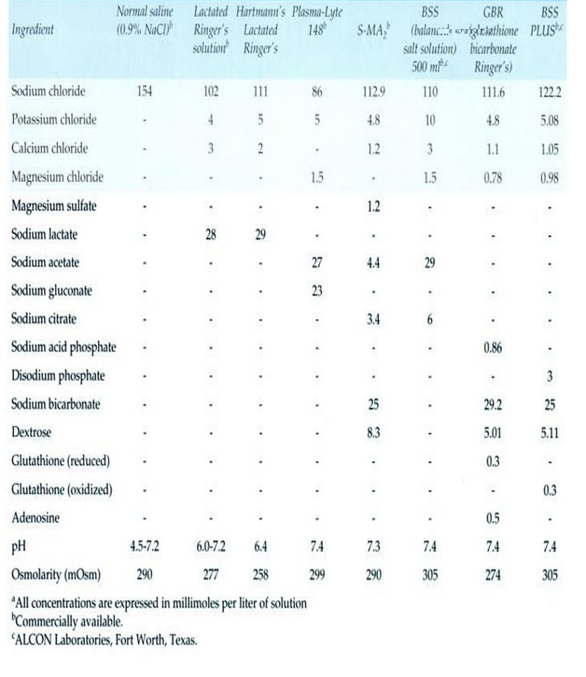Table 1: Comparing the electrolyte composition of several fluids used for intraocular surgery.
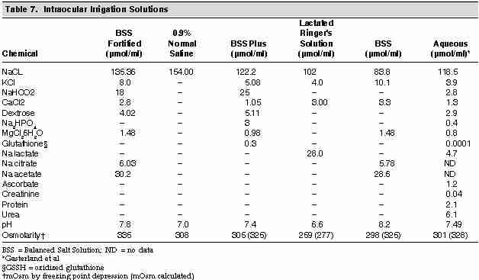
Table 2: comparing the solutes of a number of fluids for intraocular surgery to aqueous

References:
1 Phacoemulsification surgery,
Editors Vajpayee R, Sharma N, Pandey S, Titiyal J; Jaypee Bros; chapter 6,p 57
2-Intraocular Irrigating Solutions. A Clinical Study of BSS Plus® and Dextrose Bicarbonate Fortified BSS® as an Infusate during Pars Plana Vitrectomy
M Samuel, U Desai, I Strassman, M Abusamak
Indian Journal of Ophthalmol ;2003 51 3:237-242

